Overview

This final homework will provide an overview of how to manage charting. In this homework, we:

- Learn how to use chart.js to draw a line chart
- Learn how to use chart.js to draw a bar chart
- Learn how to use chart.js to draw a pie chart
- Learn about the color picker
- Learn how to use chart.js with PHP data

Exercise 1: Learning Chart.js

Chart.js is a JavaScript add-on library that helps you quickly make charts. In this library, you define an area of the screen you want the chart to be on with the canvas tag. You then use the Chart.js/JavaScript command new Chart to create the chart. There are a number of different arguments you can put into a chart, but only three are relevant for this class, the type, datasets, and options. Type defines the type of chart. Datasets specifies the data for the chart. Options specifies things like what the label of the axes will be.

Chart.js needs to render the chart AFTER the rest of the screen is built. As a result, we put the JavaScript for chart.js NEAR THE END of the HTML block, rather than at the beginning. Fundamentally, a chart.js chart will look something like this:

<body>
<canvas id=”mychartid” width=”chart width” height=”chart height” />
<script>
var ctx=document.getElementById(“mychartid”);
var myChart=new Chart(ctx,
{
type: ‘line’ or ‘bar’ or ‘pie’,
datasets: {datasets here},
options: {options here}
}
);
</script>
</body>

What is in datasets and options will vary by the chart type.

Download the file mychart.php. Run it just to see what’s there.
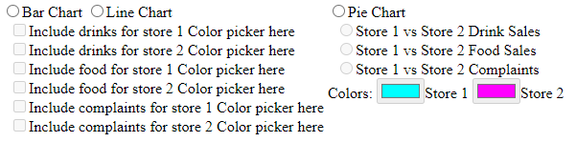

For now, we’re going to use the bottom black space to experiment with drawing charts.

To use chart.js, we have to link our code to the chart.js library. To do this, we need the line <script src="https://cdn.jsdelivr.net/npm/chart.js"></script> in our Javascript (it is already there).

Now, let’s create our canvas.

Add the following lines to the code:

<canvas id="myChart" width="1000" height="400" style="background: white;"></canvas>
</form>

<script>
var ctx=document.getElementById("myChart");
var myChart=new Chart(ctx,{ //begin Chart
type: 'line',
data:{
datasets: [
{ //begin dataset 1
data: [30,40,20,30,50],
label: "Store 1",
borderColor: "#ff0000",
fill: false
}, //end dataset 1
{ //begin dataset 2
data: [100,140,50,70,120],
label: "Store 2",
borderColor: "#00ff00",
fill: false
} //begin dataset 2
] //end datasets
},//end data
options: { //begin options
plugins: {
legend: {
display: true
}
},
scales: { //begin scales
x: {
title: {
display: true,
text: 'Months',
color: 'black'
},
grid: {color: 'black'},
ticks: {color: 'black'},
type: 'category',
labels: [1,2,3,4,5],
}, //end xAxes
y: {
title: {
text: 'Quantity',
display: true,
color: 'black'
},
grid: {color: 'black'},
ticks: {color: 'black'},
type: 'linear'
} //end yAxes
} //end scales
} //end options
});//end Chart
</script>

I know it is really difficult to type all of this, but you just aren’t going to be able to see the complete chart unless all of this stuff goes in there. Note the //begin and //end remarks as you type and make sure you have the correct open parentheses in the begin to match the end parentheses at the end. If you typed everything correctly, your webpage will now look like this:

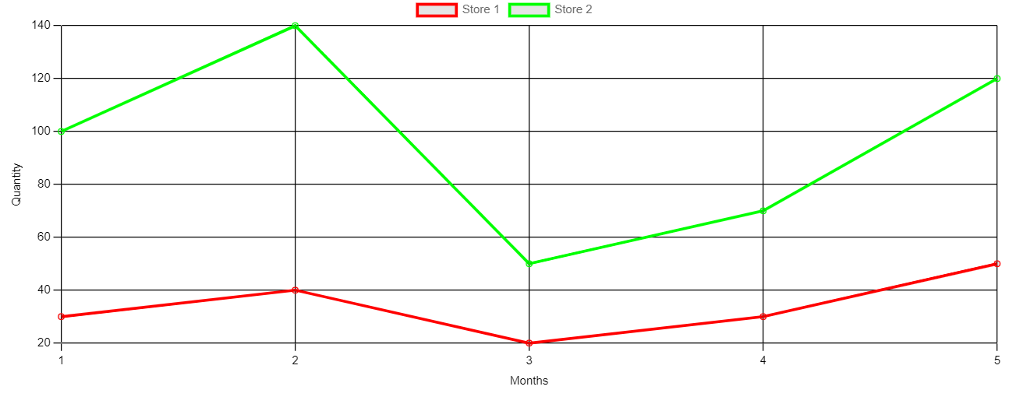

What does all this mean?

type: 'line' means the type of chart (i.e., a line chart).

labels: [1,2,3,4,5] are the labels on the X axis.

{ //begin dataset 1
data: [30,40,20,30,50],
label: "Store 1",
borderColor: "#ff0000",
fill: false
}, //end dataset 1

Is the first line on the chart. The border color denotes the color red. There are five data points (30, 40, 20, 30, 50) corresponding to our five labels.

{ //begin dataset 2
data: [100,140,50,70,120],
label: "Store 2",
borderColor: "#00ff00",
fill: false
} //begin dataset 2

Is our green line.

The long options list basically defines our X and Y axes. Those commands tell the chart that we are going to draw the X and Y axes and label them as “Month” and “Quantity” respectively.

Copy your chart code to someplace safe. We are going to need it again later, and if you lose it, you will have to retype it again. Then change the bolded text. Also delete the two fill: false lines and note the comma changes.
var myChart=new Chart(ctx,{ //begin Chart
type: 'bar',
data:{
datasets: [
{ //begin dataset 1
data: [30,40,20,30,50],
label: "Store 1",
backgroundColor: "#ff0000"
}, //end dataset 1
{ //begin dataset 2
data: [100,140,50,70,120],
label: "Store 2",
backgroundColor: "#00ff00"
} //begin dataset 2
] //end datasets
},//end data options: { //begin options

If you did everything correctly, you should see this:

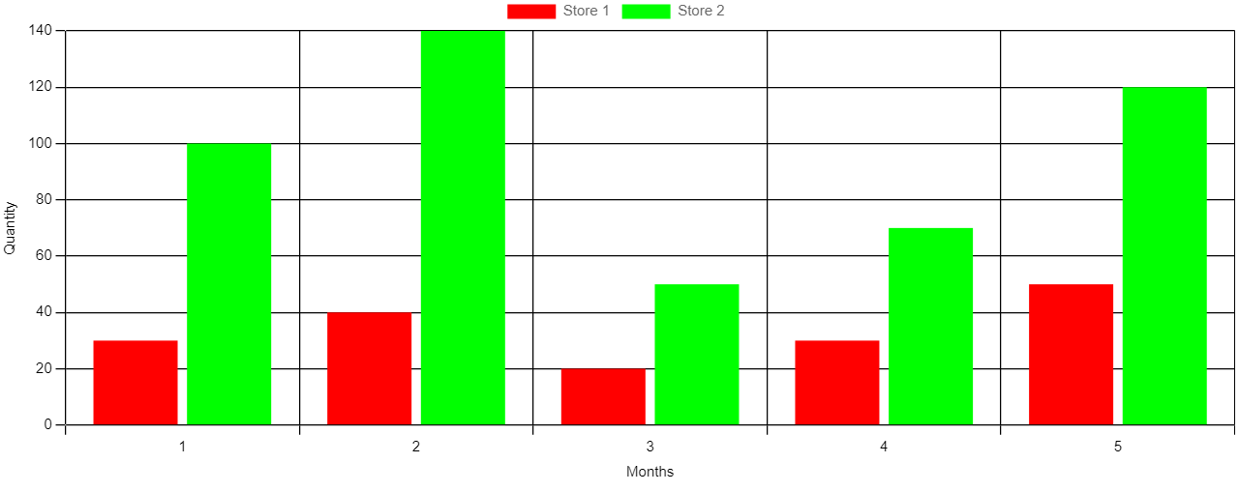

Again, save everything in the script tags somewhere safe, and then replace everything in the script tags with the following code:

<script>
var ctx=document.getElementById("myChart");
var myChart=new Chart(ctx,{ //begin Chart
type: 'pie',
data:{
labels: ['Store 1: 10','Store 2: 20', 'Store 3: 30'],
datasets: [
{ //begin dataset 1
data: [10, 20, 30],
backgroundColor: ["#ff0000", "#00ff00","#0000ff"]
} //end dataset 1
] //end datasets
}//end data
});//end Chart
</script>

If you did everything correctly, you should get this:

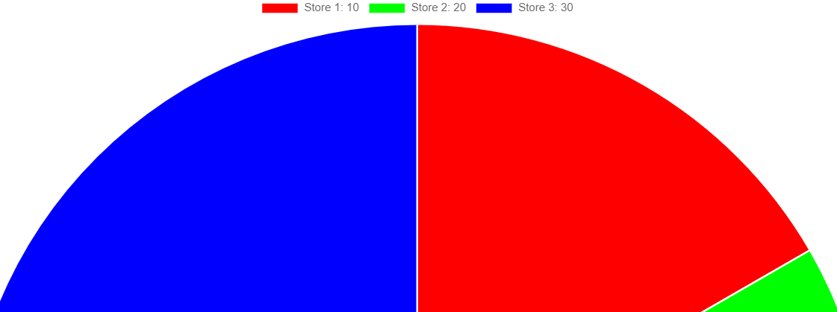

Exercise 2: The Color Picker
You will observe that one of the things we need to do with our charts is determine the colors of the various things on the chart. JavaScript has a built-in color picker. The color picker allows the user to select a color and returns a six digit hexadecimal value that maps to that color.

In the webpage, you will notice the words “Color picker here” a lot. We are going to replace those with color pickers. For the bar chart/line chart, the color pickers should be called picker followed by a number. Their default colors should be red, orange, yellow, green, blue, purple (the colors of the rainbow). These are color codes #FF0000, #FFA500, #FFFF00, #008000, #0000FF,#800080

For example, the modification to the first bar/line color picker would be:

&nbsp;&nbsp;<input type="checkbox"
id="param0"
value="Y"
disabled
/><label for="param0">Include drinks for store 1</label>
<input type="color"
id="picker0"
value="#FF0000"
disabled
/>
<br />

Then add the following lines to the function controlboxes.

function controlboxes(whichchart)
{
if (whichchart=='p')
var ispie=true;
for (x=0; x<6; x++){
document.getElementById("param"+x).disabled=ispie;
document.getElementById("picker"+x).disabled=ispie;
if (x % 2==0)
document.getElementById("value"+x).disabled=!ispie;
if (x<2)
document.getElementById("piepick"+x).disabled=!ispie;
}
}
If you did everything correctly, this is what you should see:

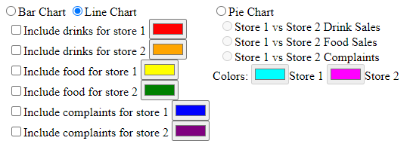

Exercise 3: Charts and the Database

Now, we can actually draw the charts.

We first need to prepare a number of SQL queries to do this. We basically need:

- An SQL query to generate the labels of the bar and line chart
- An SQL query to produce the data for the bar and line chart
- An SQL query to produce the pie chart

Create a PHP file called storemonth.php
<?php
$mydb = new PDO('mysql:host=localhost;dbname=<your database here>', ‘<your username here>’,’<your password here>’);
$stmt=$mydb->prepare("select distinct storemonth ".
"from storestats ".
"order by storemonth"
);
$stmt->execute();
$result=$stmt->fetchAll();
echo json_encode($result);
?>

Create a PHP file called storestats.php
<?php
$store=$_REQUEST['store'];
$stattype=$_REQUEST['stattype'];
$mydb = new PDO('mysql:host=localhost;dbname=<your database name', ‘<your username>’, ‘<your password>’);
$stmt=$mydb->prepare("select stat ".
"from storestats ".
"where store=:store ".
"and stattype=:stattype ".
"order by storemonth"
);
$stmt->bindParam("store",$store,PDO::PARAM_INT);
$stmt->bindParam("stattype",$stattype,PDO::PARAM_STR);
$stmt->execute();
$result=$stmt->fetchAll();
echo json_encode($result);
?>

Create a file called piestats.php
<?php
$stattype=$_REQUEST['stattype'];
$mydb = new PDO('mysql:host=localhost;dbname=<your database name', ‘<your username>’, ‘<your password>’);
$stmt=$mydb->prepare("select store, sum(stat) as sm ".
"from storestats ".
"where stattype=:stattype ".
"group by store ".
"order by store"
);
$stmt->bindParam("stattype",$stattype,PDO::PARAM_STR);
$stmt->execute();
$result=$stmt->fetchAll();
echo json_encode($result);
?>

Now we are ready to create our chart.

Just before the end form tag, add the following lines:
<canvas id="drawhere" style="height: 500px; width: 500px; border: 1px solid">

</canvas>

Now, we have to put in the code to set up our charts:
const storeparams=[1,2,1,2,1,2];
const stattype=['drinks','drinks','food','food','complaints','complaints'];
var thechart=null;
var bllabeldata=[];

function loadlabels(){
const xhttp = new XMLHttpRequest();
xhttp.onload = function() {
var monthdata = JSON.parse(this.responseText);
for (x=0; x<monthdata.length;x++)
bllabeldata.push(monthdata[x].storemonth);
}
xhttp.open("GET", "storemonth.php", true);
xhttp.send();
}

function drawpie(){
drawhere.innerHTML="";
if (!(thechart==null))
thechart.destroy();
thechart=new Chart(drawhere,{ //begin Chart
type: 'pie',
data:{
labels: ['Store 1','Store 2'],
datasets: [
{ //begin dataset 1
data: [],
backgroundColor: [piepick0.value,piepick1.value]
} //end dataset 1
] //end datasets
}//end data
});//end Chart
}

function drawbarorline(whichtype){
drawhere.innerHTML="";
if (!(thechart==null))
thechart.destroy();
var thetype='';
if (whichtype=='l')
thetype='line';
else
thetype='bar';
thechart=new Chart(drawhere,{ //begin Chart
type: thetype,
data:{
labels: bllabeldata,
datasets: []
},//end data
options: { //begin options
scales: { //begin scales
x: {
display: true,
title: { //begin scaleLable
display: true,
text: "Month"
} //end scaleLabel
}, //end xAxes
y: { //begin yAxes
display: true,
title: { //begin scaleLable
display: true,
text: 'Quantity'
} //end scaleLabel
} //end yAxes
} //end scales
} //end options
});//end Chart

}

The constant arrays storeparams and stattype are information we are sending to the PHP files to perform the queries.

The function loadlabels runs the PHP query to do labels for the bar and line charts. Drawpie sets up the pie chart, while drawbarorline draws the basic bar or line chart.

Now, we need to link these functions to the right places.

Link loadlabels to the body onload event. Then, modify controlboxes as follows:
function controlboxes(whichchart)
{
if (whichchart=='p')
var ispie=true;
for (x=0; x<6; x++){
document.getElementById("param"+x).disabled=ispie;
document.getElementById("picker"+x).disabled=ispie;
if (x % 2==0)
document.getElementById("value"+x).disabled=!ispie;
if (x<2)
document.getElementById("piepick"+x).disabled=!ispie;
}
if (ispie)
drawpie();
else
drawbarorline(whichchart);
}

If you have done everything correctly, blank bar, line and pie charts will appear when you click those radio buttons:
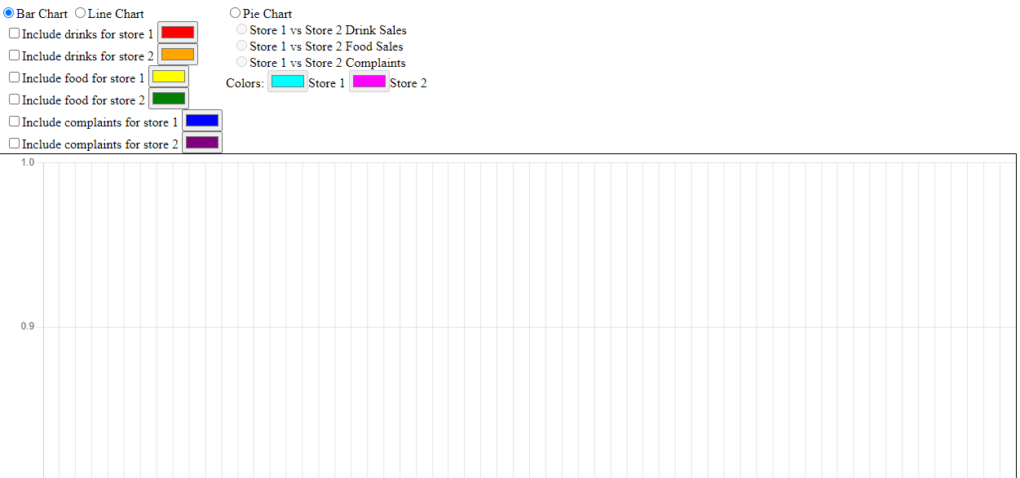

Now let’s actually fill in the data. The pie chart is significantly easier, so let’s do that first. Create the following function:
function dopie(){
var x=0;
var haschecked=false;
while (x<3 && ! haschecked)
if (document.getElementsByName("whichpie").item(x).checked)
haschecked=true;
else
x++;
if (x<3){
thechart.options.plugins.title.text=stattype[x*2].toUpperCase();
thechart.options.plugins.title.display=true;
const xhttp = new XMLHttpRequest();
xhttp.onload = function() {
var phpdata = JSON.parse(this.responseText);
thechart.data.datasets[0].data=[];
for (x=0; x<phpdata.length;x++)
thechart.data.datasets[0].data.push(phpdata[x].sm);
thechart.update();
}
xhttp.open("GET", "piestats.php?stattype="+stattype[x*2], true);
xhttp.send();

}

}

Link this function to the whichpie radio buttons. If you did everything correctly, you should get:

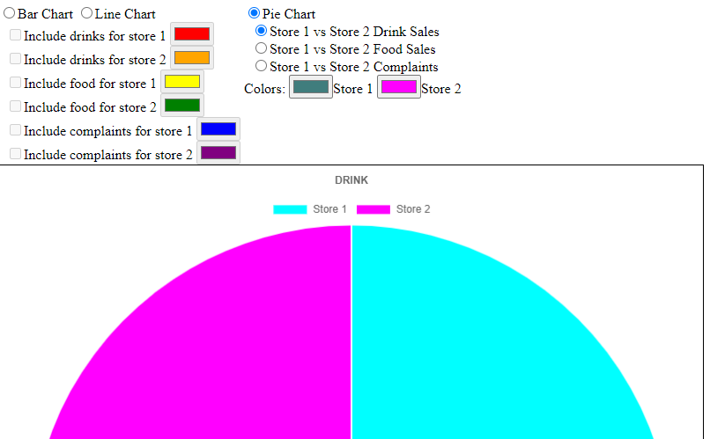

We also want to set it so changing the color picker values changes the color in the chart.

Add the following function:
function dopiecolor(whichcolor){
thechart.data.datasets[0].backgroundColor[whichcolor]=document.getElementById("piepick"+whichcolor).value;
thechart.update();
}

Link this to the color pickers associated with the pie chart:
<input type="color"
id="piepick0"
value="#00FFFF"
oninput="dopiecolor(0);"
disabled
/><label for="piepick0">Store 1</label>
<input type="color"
id="piepick1"
value="#FF00FF"
oninput="dopiecolor(1);"
disabled
/><label for="piepick1">Store 2</label>
If you did this correctly, changing the color picker will change the pie chart colors.
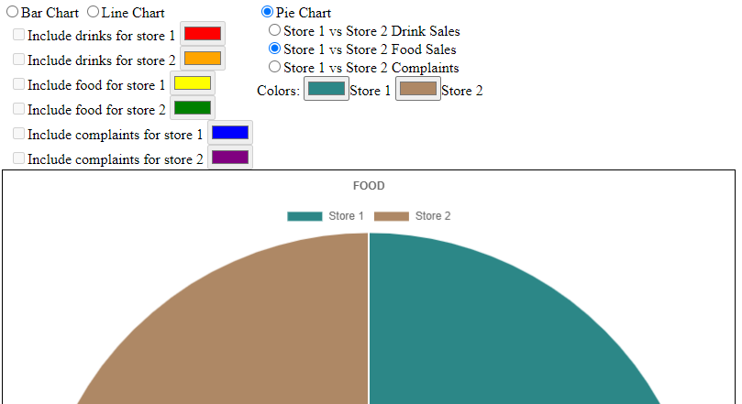

Now let’s draw the line and bar graphs:
var bllinedata=[,,,,,];

function dobarline(whichcheck){

if (document.getElementById("param"+whichcheck).checked){
const xhttp = new XMLHttpRequest();
xhttp.onload = function() {
var phpdata = JSON.parse(this.responseText);
var linedata=[];
for (x=0; x<phpdata.length;x++)
linedata.push(phpdata[x].stat);
bllinedata[whichcheck]=linedata;
refreshbarline();
}
xhttp.open("GET",
"storestats.php?store="+storeparams[whichcheck]+"&stattype="+stattype[whichcheck],
true
);
xhttp.send();
}
else
refreshbarline();
}

function refreshbarline(){
var x=0;
var y=0;
var chartdatatsruc=null;
thechart.data.datasets=[];
for (x=0; x<storeparams.length; x++){
if (document.getElementById("param"+x).checked){
if (barchart.checked)
chartdatastruc={data: [],
label: 'Store '+storeparams[x]+' '+stattype[x],
backgroundColor: document.getElementById("picker"+x).value,
fill: true
};
else
chartdatastruc={data: [],
label: 'Store '+storeparams[x]+' '+stattype[x],
borderColor: document.getElementById("picker"+x).value,
fill: false
};

chartdatastruc.data=bllinedata[x];
thechart.data.datasets.push(chartdatastruc);
}
}
thechart.update();
}

We also need to add one line to drawbarorline:
function drawbarorline(whichtype){
.
.
.
refreshbarline();
}

Finally, for all the bar/line color pickers, set the oninput event to oninput="refreshbarline();"

Also, for all checkboxes, link the onclick to dobarline();

If you did everything correctly, you should be able to do this:
